Postcard Lg Message/Sm Schedule
If you need assistance, please call customer service at (800)348.2886.
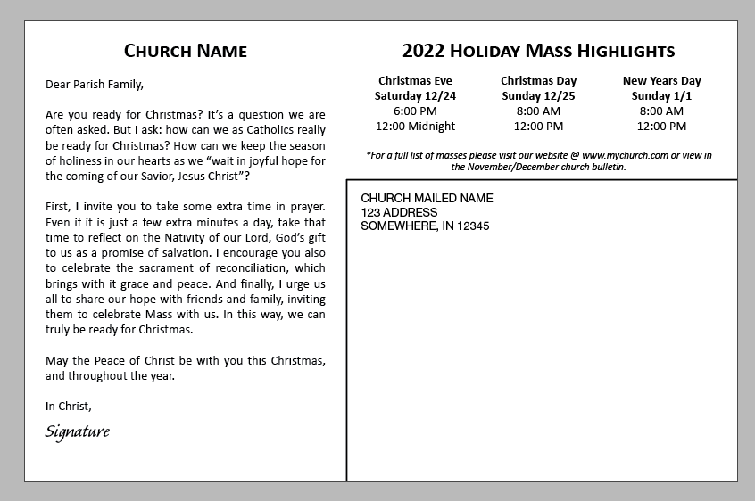

Sample:

1. Choose Design: Angel, Angel-Bilingual, Nativity, Traditional,
Traditional-Bilingual, or Journey

2. Choose from 3 approved fonts: Calibri, Cambria, or Segoe Script
If you would like to use a different font, you will need to save this document as a .pdf prior to submitting to christmas@osv.com.

3. Choose Message: A, A-Bilingual, B, C, or Custom

4. Provide Signature: Send .jpeg or .Pdf file of signature or typeset here

5. Provide Church Return Address for Postcard here:
Church Name, Address, ST, Zip

6.Provide Information Below: Messege (if Custom) & Small Schedule
Church Name
If Custom Messege, enter here:
(leave blank for standard A, A-Bilingual, B or C msg)

Please do not exceed the size of this text box or text may be cut off.

Update Highlighted info:

Header: 2022 Holiday Mass Highlights

Footer:
*For a full list of masses please visit our website @ www.mychurch.com or view in the November/December church bulletin.

Enter your small schedule below
(Please stay within the cells of table)
Event here  Date here  Mass Time here  Mass Time here | Event here  Date here  Mass Time here  Mass Time here | Event here  Date here  Mass Time here  Mass Time here

